Rack Mount Patch Panel
ODU-L31
Overview
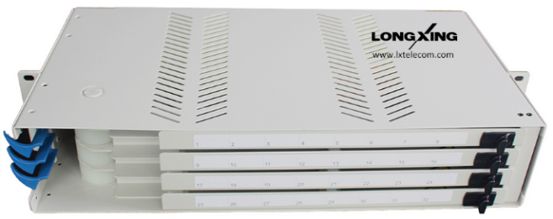
This rack mount patch panel is used to terminate the providers’ side of an optical fiber cable. It is a steel unit with provision to splice up to external optical fibers to pigtails. The splices and spare optical fibers are stored on the splice trays provided, while the pigtails are located in simplex through connectors at the patch panels in front of the splice trays.It is an ideal solution for rack or cabinet mounting in compact areas. This unit provides excellent fiber patching management.

Features
● Top quality steel with electrostatic painted ensures the strong body and pleasing appearance.
- For standard 19", 21’’and 23’’ racks use (other rack width options available on request).
- Fully stable patch panel, no risk of movement.
- Easy operations: Rotate style.
- Cable can be entered from rear; patch cords go out from left front
- Total front access for users.
- LongXing adapter panels are used for quick and easy adapter installations.
- Protected patch panel offers secure environment for adapters, patch cords and pigtails.
- High Density, see the capacity chart below.
- Adoptable adapter types: FC, SC simplex adapters and LC duplex adapters.

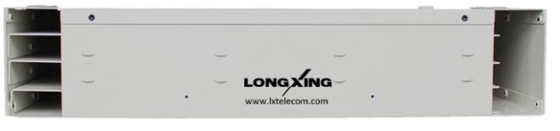

Dimensions and Capability
 | Height | Depth(mm) | Width | Capacity (Cores)
 |  |  |  | FC | SC | LC
 | 1U | 240 | 19’’/21’’/23’’ | 24 | 24 | 48
 | 2U | 240 | 19’’/21’’/23’’ | 48 | 48 | 96
 | 3U | 240 | 19’’/21’’/23’’ | 72 | 72 | 144
* Height is upon request.
Operation Conditions
Temperature | -5℃ -- 60℃
Humidity | 90% at 30℃
Air Pressure | 70kPa – 106kPa

Shipping Information
Package Contents | Patch panel, 1 unit
Package Dimensions(W*H*D) | It depends on the dimensions of the product
Material | Carton box
Weight | It depends on the dimensions of the product
Lead Time | 10-15 working days normally

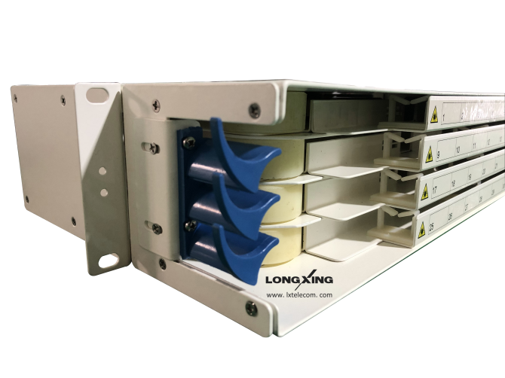
Part Details
